Invention League Program – Student Materials

- Welcome Letter
- Timeline
- Invention Questionnaire
- Rules for Journal Keeping
- Intent to Invent Form (due February 5, 2017)
- Parent Permission Form (due February 5, 2017)
- Naming the Invention
- Display Board Tips
- Patent Search
- Presentation Practice Questions
- Sample Scoring Sheet

George G. Dodge Intermediate School

2017 Invention League
Dear Dodge families,
Dodge is participating in the 2017 Invention League (formerly Invention Convention)! The Invention League is an academic option in which students use their imaginations and problem solving ability to research, plan, and create an invention. We will hold a local Invention Convention on Friday, March 3, 2017.
We held our Invention League Kick-off Assembly on Friday, January 13, 2017 and we encouraged students to think about problems in their everyday lives that a new invention could solve. Students may choose to participate Once students decide they want to participate, he or she must return the Parent Permission and Intent to Invent forms to school by February 5, 2017. When these forms have been returned, your child will receive additional information needed to complete the project.
The Invention Convention is an at home and in-school (IE) project, so please consider the time commitment before agreeing to participate. It is an OPTIONAL project, but a very worthwhile learning activity. Parents are encouraged to help their student with acquiring materials, building prototypes, and prompting their student’s critical thinking about his/her ideas and design, but all ideas must be original to the student. Remember, the students are competing for scholarships and other prizes and the work needs to be the students’ own work. The students’ responsibilities are as follows:

- Choose a problem and brainstorm solutions
- Determine if the idea is already invented (patent search)
- Select a partner to work with (optional)
- Document research conducted and data collected in the development of the invention
- Build and modify a prototype—no larger than 2’ x 3’
- Document all steps and tests of the prototype in a journal
- Create an Invention display board
- Practice the presentation of the invention
- Bring journal, board, and prototype to the GGD Invention League on March 3, 2017
This is sure to be an exciting and memorable learning experience for your child. Your support and cooperation are greatly appreciated.

Thank you,
Sixth Grade Invention League Coordinators

Congratulations!

You have accepted the challenge of participating in the 2017 Invention League! All the handouts and information you will need to complete your project are contained in this packet. Read your timeline carefully so you know which handouts you should be reading as you work on your project. The most successful inventions are the simplest, so just remember to Keep It Simple.

Four Common Means to Inventing

- Improve upon a product. Change something and make it better.
- Combine ideas. Put two or more inventions together to create something new.
- Create a new use for an item.
- Create an original invention—a totally new product or idea.

Invention League Timeline

Now—February 5
- Discuss inventions and the problems they solve. Use the Invention Questionnaire to identify a problem and an invention that may solve it. Books to read: Milo’s Great Invention by Andrew Clements, So You Want to Be An Inventor by Judith St. George and David Small, and Imaginative Inventions by Charise Harper
- Decide on a problem. Brainstorm solutions for the problem. Complete the brainstorming section in your journal (you can find the journal online here: http://www.inventionleague.org/wp-content/uploads/Invention-Leagues-Invention-Convention-Student-Journal.pdf. You can print it out and write directly in it (in ink), or download the PDF and type directly in the document and print it out when it’s complete).
- Research your idea to make sure it does not already exist. Do a patent search for your idea (instructions are included).
- Complete and return the Intent to Invent and Parent Permission forms—due Friday, February 5, 2017.

Now—February 15
- Experiment with your idea. Complete the experiment page of your journal. If your idea is not successful, try another … and another … and another until you are satisfied that it works.
- Complete the idea pages in your journal.

February 15-February 28
- Complete your invention and your rough draft Student Journal.
- Create a “catchy” name for your invention. See the Naming Your Invention handout for guidance.
- Create a display board for your invention. Information included on your board should be typed. Be creative and make the board colorful. See the Tips for A Quality Display handout for guidance. The Internet also has many websites devoted to creating quality display boards.

February 28-March 2
- Finalize all aspects of your project. Continue to work on your display and make sure everything is neat and complete.
- Optional: You may want to ask family members or friends to write an endorsement for your new invention. Include these with your display. Include patent research as well.
- Practice your presentation. Have someone ask you questions about your invention so you are comfortable talking to the judges. See the Inventor Questions handout for guidance.

March 3
George G. Dodge Invention League. Make sure you have:
- Your invention prototype
- Completed student journal (The journal will need to be written neatly in ink or printed out)
- Display board

State Competition April, 2017

Invention Questionnaire

Use this form to ask family members and friends about problems that need to be solved. This may help you think of an idea for an invention. (Optional—does not need to be returned)

What does not work as well as you would like it to work?

What problems would you like to have solved?

At home?

At school?

Other (car, store, etc.)?

If you could invent something to make your life easier, what would you invent?

Intent to Invent Form

Student Inventor: __________________________________ Grade: _______ Advisory: __________
Will you be working with a partner (partners are optional)? ☐ Yes ☐ No
If you are working with a partner, please indicate your partner’s information below:
Partner’s Name:___________________________________ Grade: _______ Advisory:__________
1. Brief description of my invention:

2. I have determined to the best of my ability that my invention will be original by taking the following steps:

3. I plan to use the following materials in my invention:

Invention Convention Permission Form

Due February 5, 2017

My child, ______________________________has my permission to participate in the 2017 Invention League. I understand that he/she will need my support and assistance while completing this project.

Student Signature:_______________________________________Date:________________

Parent Signature: _______________________________________ Date:________________

Parent Email: _______________________________________

Rules for Journal Keeping
- Make notes each day about the things you do and learn while working on your invention.
- Record your idea and how you got it.
- Write about problems you encounter and how you solve them.
- Add sketches and drawings to make things clear.
- List all parts, sources, and cost of materials.
- Date all entries at the time they are made.
- You may keep a “rough draft journal” during the process, but will need to transfer the information to the official Invention League journal before the competition.
- The official Invention League journal must be written in ink or printed out if you type into the PDF of the journal available online here: http://www.inventionleague.org/wp-content/uploads/Invention-Leagues-Invention-Convention-Student-Journal.pdf

Naming the Invention

An invention can be named in one of the following ways:
- Using the inventor’s name:
  - Levi Strauss = Levi jeans
  - Louis Braille = Braille alphabet system for the blind
- Using the components or ingredients of the invention:
  - Root beer, peanut butter

Using initials or acronyms:
  - IBM, SCUBA

Using word combinations (notice repeated consonant sounds/rhyming words):
  - Hula Hoop, Pudding Pops, Kit Kat, Cap’n Crunch

Using the product’s function:
  - Earmuffs, hairbrush, Swiffer
Tips for a Quality Display

Design your display board so that it represents your invention clearly and attractively.
- Use a tri-fold board so it is sturdy enough to stand by itself and large enough to show pictures and drawings.
  - A tri-fold display board can be purchased at office supply stores.
- Titles and subtitles should be large and clear.
- If possible, all information for the board should be typed and printed from a computer.
- Use colorful paper to make borders and frames for your titles and information.
- Do not leave large empty spaces on the display board. Include photos and drawings.
- Balance the arrangement of materials on the board.
- Rubber cement or double-sided tape is neater than white school glue.
- BE CREATIVE!!!

Sample Invention Display Layout

Hundreds of examples of display boards can be found online through a simple image search using keywords like Invention Convention display board. Here are a few general layouts to get you started:
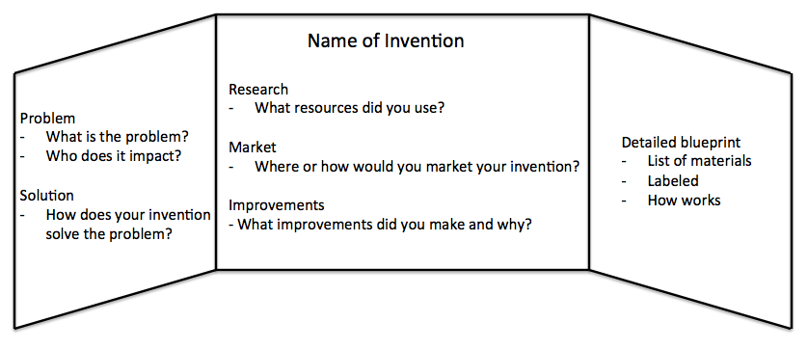

Patent Search
You must complete a patent search of your invention to verify the originality of your invention. Here are some online resources to help you get started:
- http://www.uspto.gov/video/cbt/ptrcsearching/
- http://www.uspto.gov/learning-and-resources/support-centers/patent-and-trademark-resource-centers-ptrc/resources/seven
- http://www.uspto.gov/sites/default/files/documents/7_Step_US_Patent_Search_Strategy_Guide_2015_rev.pdf
- http://www.uspto.gov/patents-application-process/search-patents

Presentation Practice Questions
Have someone ask you these and other questions to practice your presentation.
- What problem does your invention solve?
- How did you get your idea?
- How do you know that this has not been invented before?
- Are you interested in pursuing a patent?
- What was the most difficult part of creating your invention?
- Who would benefit from your invention? How would they benefit?
- How could you market your product?
- Explain your student journal. How was it helpful?
- Where could you go next with your invention

